Sept, Oct, Nov 2015 Newsletter

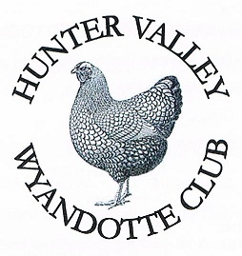

President – Alan Nightingale

Secretary – Amanda Winney
3 First Avenue
Rutherford NSW 2320
0422 237 277

Email: huntervalleywyandotteclub@gmail.com

Website: huntervalleywyandotteclub.weebly.com
Club Committee

Life Member –Dallas Smith

Patrons – Tony Shubert, Grafton Shelton, Bert Hewitt

President – Alan Nightingale
Ph: 0437 277 004 Email: kazm@live.com.au

Vice Presidents – Graeme Lambert, Tony Shubert, Grafton Shelton

Secretary/Treasurer – Amanda Winney
PH: 0422 237 277
Email: huntervalleywyandotteclub@gmail.com

Assistant Secretary – Greg Owens

Management Committee – Alan Nightingale, Amanda Winney, Andrew Stevenson

Show Committee – Greg Owens, Cathy Lambert,
Geoff Bushby, Fiona Fredrick.

Auction Committee – Graeme Lambert, Kim Nightingale, Victoria Bushby.

Editor & Webmaster – Alan Nightingale
Presidents Report
Welcome to my first Presidents Report, I would like to thank all the members for intrusting me as the President of The Hunter Valley Wyandotte Club. A club that is so steeped in history with most of the best Wyandotte breeders, Judges and exhibitors have had some involvement with this club over its 31 year history in some form or another. Firstly I would like to thank Andrew Stevenson for his leadership over the past three years and look forward to working with him as part of the clubs management committee, Andrew staying on in this roll speaks volumes for his passion and love for both the Wyandotte and the Hunter Valley Club. I would like to welcome the newly elected committee to their positions and look forward to working closely with them for the betterment of the Club and the Wyandotte breed. A full list of the committee can be seen on the inside front cover of this newsletter.
For those members who may not know me please allow me to introduce myself. I have been breeding Wyandottes for seven years with my wife Kim and we exhibit as The Nightingale Family along with our two kids Zali (6) and Max (5). We have been members of the Hunter Valley Club and the Wyandotte Club of Australia for the past five years. I was elected as Secretary of the club in 2013 were as a part of a strong committee we had record numbers at our Annual show and auction. In 2014 I was injured in a work accident in a mine and was unable to continue in this roll and stood down from the Secretary position as I believed I could not do the position or the club justice at the time. As exhibitors over the years we have shown sizable teams of large Wyandottes at The Sydney Royal, Central West Wyandotte Club, Sydney Wyandotte Club, NSW Wyandotte Club, The Centenary Show, Quirindi Feature Show, Central Coast Show to name a few. The amount of birds we now breed and exhibit have been greatly reduced over the past year or so. We breed and exhibit in large fowl, Blue Laced Gold, Gold Laced, Silver Laced, Blue, Black and Red, in bantam Blue and Black. Our Stud is situated in the Upper Hunter Valley near Denman.
By now everyone should be hatching their chickens and starting to see them progress through the various stages of development. At our stud it is certainly a very exciting time for the kids as well as myself and Kim. There already seems to be some mixed results out and about with both fertility as well as hatchability but I hope all our members are having a great season and look forward to seeing your result from the breeding season at our 2016 Annual Show.
I would like to touch on the Australian Wyandotte Clubs 2015 Centenary show and say how great it was to see so many Hunter Valley Members out at Mudgee and taking their share of the spoils home with them. I would like to again congratulate Peter Smallpiece for his Grand Champion White Bantam that was superbly presented by Peter. Tony and Val Shubert for their Champion Self Coloured of show with a large black hen, she was a stand out in this section beating some lovely birds presented by Marie Tanzer. Brad and Ann Anderson for their Champion Columbian of show. The Stevenson’s with both their Large Buffs and Cuckoos, The Bushby’s with their Large Partridge and the Lamberts with their Buff Columbian Bantams were among the notable winners. Also we were fortunate enough to win five variety champions in Blue Laced Gold, Blue, Red and Laced Blue. It was fantastic to see the team that the club put together consisting of The Stevenson’s, The Shubert’s and The Bushby’s winning the team event and earning the club $100 and a wonderful trophy for the club to present each year as a perpetual trophy for the feature breed award. The friendships that were made and catching up with old friends was a great way to spend a top weekend looking at the 950 birds that were presented for the judges. The auction held on the Sunday saw some very spirited bidding and some club members bought well as well as got nice prices for quality birds they had in the auction. So again a big congratulations to you all. These results typifies that The Hunter Valley Wyandotte Club is certainly at the top when it comes to the colour varieties.
I must say that the celebration of the 100 years of the Wyandotte starting at The Sydney Royal Easter Show and continuing throughout the show season was fantastic, the quality of birds that were benched at all the Wyandotte Shows across the state by our members were of extremely high standard and each and every member should look back over the past year and be very proud of their achievements. The Wyandotte Club of Australia launched the new book during the year and is a must have for all Wyandotte enthusiasts.
The Hunter Valley Annual Show for the 2015 year was not to the lofty high that we have come to expect from the club, this was due to a plethora of reasons and we must all look at anything that any of us can do to improve from this for next year. We need to look at both number of birds but more importantly the number of individual exhibitors. At the 2013 show we did have large entries but we also had 45 individual exhibitors, were as this year the number was around 25 exhibitors. I would like to ask each and every member to encourage one person to become a member and then help them with exhibiting a couple of birds at our show, in a sort of a mentor roll.
As the new President of the club I would like to invite any one that has anything they would like to contribute to the newsletter to send any ideas or articles to myself or Amanda for inclusion, this could be anything from advertising your sale birds (inside the back cover will be set aside for this as well as sponsor ads at no charge to financial members) to putting together an article on your favourite variety and how you breed them. I would also put it out to any of the older/experienced members to consider penning something on their time with the Wyandotte for the newsletter as I am sure there are a lot of people including myself that would be interested in hearing your story. Whilst on your favourite variety it would be great if you could sponsor it at our annual show, $20 would pay for the trophy and ribbon which would be presented in your name and will help encourage more interest in that particular variety, these trophies are of extremely high quality and well worth winning.
In closing I would like to say that this is your club and the committee are there as custodians for the club and its members. Without your membership, support and input the club will not be as good as it could be so please think of what you would like to get out of this wonderful hobby. I look forward in seeing you all soon at a show or a meeting. But in the meantime if you have something you need to say my lines of communication are open and my contact details can be found in this newsletter. So please stay safe, look out for each other and support our sponsors
Regards
Alan Nightingale

Hunter Valley Wyandotte Club

Committee Meeting 27th September, 2015

Present: Alan Nightingale, Graeme Lambert. Grafton Shelton, Amanda Winney, Greg Owens

Meeting commenced 10.00 am

Constitution:
Discussion re the best way to go with a constitution for the Club
Wyandotte Club of Australia – use Dept. of Fair Trading as the foundation for theirs.
Amanda to contact Brad Anderson for advice in the mean time we will read, review, recommend and consider the Dept. of Fair Trading as our foundation with members to bring recommendations to the next meeting

Judges for 2016 Show
Amanda has the invitations ready to go – she is chasing up addresses.

Newsletter:
Alan has received permission from Duane Rhall to reprint articles on pencilled and partridge breeds for inclusion in the upcoming newsletters.

Also to be included:
Minutes of the AGM, President, Secretary and Treasurer's report's. Amanda to submit a show report and results and Judges reports for inclusion. Pictures of recent show if available
Greg to get it printed via Rutherford Officeworks (get details from Amanda)
Alan to edit the newsletters and send out

Trophies
There are eight variety glass trophies and three ribbons left over from last show. Greg to contact Dallas Smith to see if we can get some UK Wyandotte rosettes as awards for our 2016 show. Amanda to get quotes for trophies and ribbons for next meeting. Alan to contact The Australian Wyandotte Club about supplying some ribbons.

Audit
It was agreed that we employ Robert Ryan Accounting Services to perform our annual 2014/2015 audit. Greg to contact Robert to discuss the fee that he will charge and the logistics required.

Club Website
Alan to update the website, Amanda to supply photos and show results for inclusion

Auction
Amanda to contact Andrew Stevenson to confirm availability of our auctioneer
Meeting closed at 11.55 am
Next Meeting will be in approximately 6 weeks (early November)

2015 Annual Show Results
The Hunter Valley Wyandotte Club would like to thank everyone who exhibited at our annual Show.
Congratulations to all the major winners
And a huge THANK’S to our Wonderful Sponsors
Judges
Large - Andy Vardy
Bantam – Mick Holmes

Champion Bird of Show – Mick & Shirley Young – Bantam White
Reserve Champion Bird of Show – Darryl Bishop – Large White Ckl
Champion Bantam – Mick & Shirley Young - White
Champion Large – Darryl Bishop – White Ckl
Champion Junior – Jack Trappel
Champion Breeding Pair – Darryl Bishop

A full comprehensive show report and results will be published when they are made available

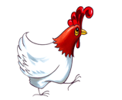
The Funny Fowl
Why did the chicken cross the basketball court? He heard the referee calling fowls
On which side does a chicken have the most feathers? On the outside
Why couldn’t the chicken find her eggs? Because she mislaid them
Why did the chicken cross the playground? To get to the other slide
How do chickens dance? Chick to chick
What did the chicken do when he saw a bucket of fried chicken? Kicked the bucket

With the feature breed at our 2016 annual show being Partridge and Silver Pencilled I thought it would be of interest to reproduce an article on the Partridge Wyandotte with permission from the Wyandotte Club of Australia. Reproduced in 2000, Author Unknown - Alan
BREEDING PARTRIDGE WYANDOTTES
Perfection of Colour a Difficult Attainment
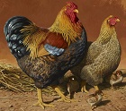
“The cock a thing of beauty, the hen a work of art” I do not know to whom I am indebted for this quotation, which has lingered in my memory ever since. I first read it in “Poultry world” but it aptly describes the best representatives of the partridge-marked breeds of poultry. No colour pattern ever caught the popular fancy as did the partridge, nor were prices ever excelled by other varieties. The breeding of perfect specimens is a complicated business, and this perhaps is the reason why, in these days of self-coloured birds winning all the major awards, partridge varieties have lost ground. The Wyandotte, however in particular the partridge large fowl has taken a new lease of life, and is refreshing to find such fine specimens as have on view at recent shows.
Double Mating Necessary
The standard of the Partridge Wyandotte demands the sexes being so unlike each other that it is impossible to produce them from one mating. In fact, I have always considered that this variety provides the outstanding example of what double mating can achieve, and by no stretch of imagination can a breeding specimen be mistaken for a show bench champion.
In the perfect cock the neck hackle is a sweet golden colour, each feather being distinctly striped with black; this stripe must be well defined and of a deep, brilliant colour. The saddle hackle will match the neck. The wing bows, shoulders and back are a rich, brilliant red, with no tendency to harsh brick-red, nor deep enough to be mistaken for brownish-red. The wing bay, or diamond, is chestnut brown, and the remainder of the body black, with a rich green sheen.

Hackle Faults
Faults are frequently found in the hackle and saddle. The stripe may be dull and weak in colour, or shafted with gold, on the other hand, it may be excessive in black and double laced or run through, thus spoiling the sharp contrast of the two colours. The red of the back and wing may be intermixed with black, and the breast and fluff tinged with brown or red. The base of the sickle and tail roots should be carefully examined to see that they are sound to the skin. Frequently, if under colour is too light, some weakness is found here. The cock which answers most nearly to this description, and is free from the faults named, is the one to head the pen of cockerel breeders.
Cockerel-Breeding Hens
The hens to produce such are very unlike the standard. The first requirement is that their neck hackles shall be of the desirable golden shade, and soundly striped with black; any which do not come up to requirements in this respect must be discarded immediately. The hackles must be full and flowering, not scanty nor short. Tails must be sound black throughout, and if the top feathers are curved and broad so much the better. Body colour will vary somewhat, but will generally be of a brownish-black or dun cast, some of the feathers towards the cushion being tinged with gold. A little blaze of red may occur on the shoulder, and so long as this is not excessive it will serve to intensify the colour at this point in the cockerels. Under colour must be as dark as possible, and flights sound black
The Exhibition Pullet
The pullet which fulfil the standard requirements are so striking in appearance, but, if anything, are more difficult to produce than the cocks. The neck hackle must again be a nice shade of golden yellow, each feather neatly striped with black. The lower hackle feather will probably be pencilled after the pattern of the body feathers is a soft, delicate shade of brown, and one which is difficult to convey by description. It has been aptly called “mousey” colour, the colour of a “dead oak leaf” and must not err on the side of darkness and become almost chocolate, nor must it be ruddy, chestnut or bricky. Equally bad is the fault known as “washiness,” in which the ground colour is almost clay-brown. Perhaps the best description is that it must be but one shade deeper than the colour nutmeg.
On each feather occurs the pencilling which is the main feature of the breed. This follows the outline of the feather but does not start on the outer edge. Commencing at the outside of the feather, we find, first, a band of brown ground colour, next a sharply defined jet black marking, then the ground colour, again the “pencilled” markings, ground colour, and so on. It is usual to find three such pencillings on each feather, and a really excellent specimen may have four. The tail should be black and the under colour deep grey.
Common Defects
Common faults are the breast pencilling running out and being badly defined immediately under the throat, pencilling “breaking” on the cushion, and tail coverts being barred instead of correctly marked. When the pencilling is broken the specimen may appear all right from the outside of the pen, but on being handled it is seen that, whilst the end of the feather is correctly marked, the pencilling fails to go to the feather roots, and indistinct, blurred markings are found there. Very finely pencilled specimens which are otherwise exquisite in their beauty frequently fail on the fluff, at which point the markings are generally good, and a specimen with poor pencilling here is a poor specimen indeed.
Mating for Pullet-breeding
To make up a pullet-breeding pen the best females should be procured, and if some of these are rather heavy in their black markings it will not matter a great deal so long as they are correctly mated. These will be found to be the best in under colour, and will help to keep this feature right. The cockerel to head the pen will not be the gorgeous fellow as his near relative in the other pen. His hackle will be duller and deeper in colour, and his red not so intense and vivid. Some breeders are not particular about his striping either, but I would prefer his saddle being well striped, as I have an idea that this helps cushion marking in the pullets. His breast and fluff will not be perfectly sound, nor is it desirable that it should be so. Red marking on these parts will be likely to insure better pencilling and ground colour in the progeny. His legs should be rich yellow, as many of the females will be found to have dark legs, owing to most attention having being paid to markings, and improvement should worked for in this direction.
Characteristics of the Chicks
When partridge-coloured chicks are coming into their first feather they bear little resemblance to the beautiful creature it is hoped they will become, and much heartburning has been caused by novices not knowing what to expect. The first feathers are generally drab or greyish-brown, and frequently barred of tipped with black. Flights are grey and black, and the chicks generally an unprepossessing creature.
As they come into their second feather, however, pencilling is noticed on the breast and shoulders, and a little may appear on the back. The cockerels begin to show the solid breast with just a little blaze of colour on the back.
Good markings finally appear with adult plumage, and it is then that the pullets must be carefully handled to see that they are correctly marked and the ground colour clean and free from ticking and peppering between the pencilling. The cockerels should be examined to see that they are up to standard, and any failing badly in the hackle and black must be discarded. Good specimens improve with age, and a show fowl will have a normal exhibition life of three or four seasons.
Breeding Tips
With any colour that is difficult to breed and short on breeders, it is wise to continually be on the lookout for new blood to create a new family line within your own stud. An average bird mated to a superior bloodline will be improved by the cross. The worth of such a cross is increased vigour and perhaps an increase in size, which is one of the main problems facing breeders is maintaining the size we have. Once you have attained a point be very careful not to lose that point in the quest for another.
Line breeding is the only way to make any headway. With superior ancestors in the pedigree and several generations of sound breeding methods you should reap the rewards.
The great breeders and poultry experts, the late Athol Giles, often said they used to send away a setting of eggs to be reared in a different part of the country, then bring some back as breeders and it was as good as an outcross.
Always remember the hen only influences her own chicks, the male influences everything he is mated too, therefore it is important to know that he is as sound a breeding proposition as you can find.
Don’t think all geese are swans, be critical of what you have and always have a plan of some sort don’t just breed from year to year. Great breeders breed in cycles.

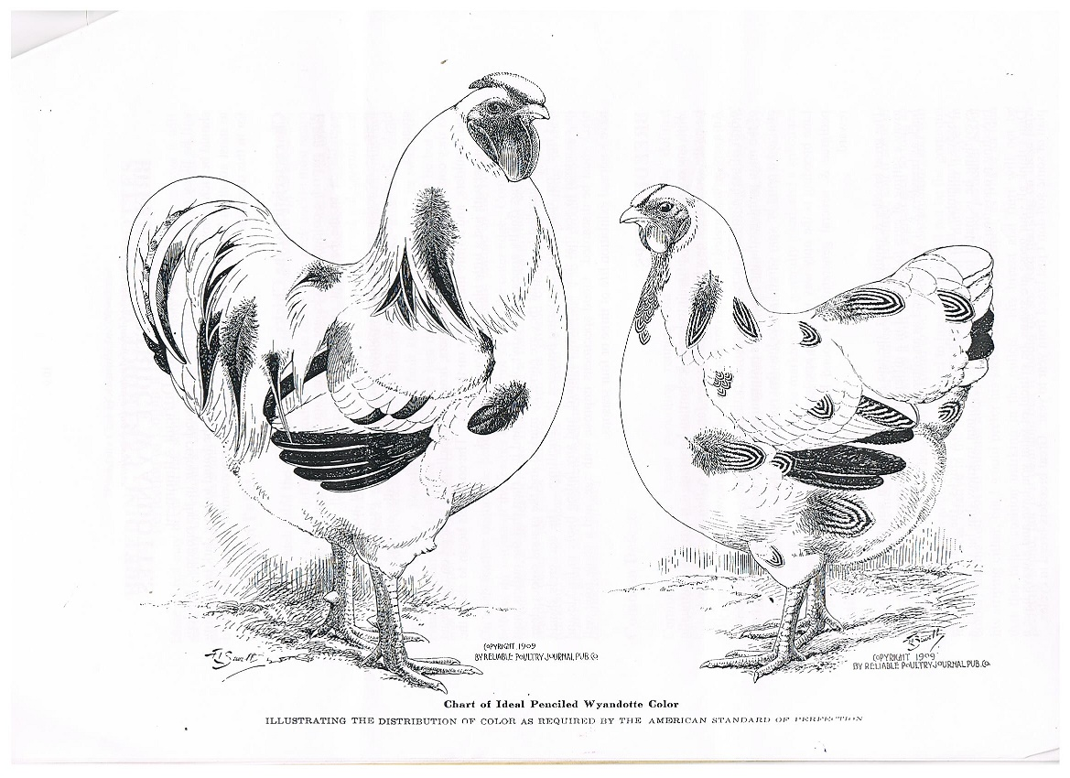

Partridge Wyandotte Since 1964
Written by Tom Mumford
Reproduced with permission of The Wyandotte Club of Australia

I commenced breeding Partridge Wyandottes with a trio of Cockerel Breeders I purchased from Mr, Frank Catt in 1964. There was no dispute that these birds were “The Goods” because they produced winners in 1965. I was lucky in that I had a good foundation. I consider therefore that I was lucky twice, first because of the quality of these birds and second because these bantams were the right choice and I did not waste time later on in needing to change breed or colour.
In later years I become interested in the Standard Partridge Wyandotte, all I may have learned did not alter alter and the interest continued and grew. I also developed an interest in books and started collecting them. I could not pass a second hand book shop without a look. The more books I gathered the more I realised there was very little in the way of help to know what to mate and what to discard.
The two items well written about was ORIGIN and lengthy wording on what must be in the breeding pen. Not only did they tell one how to produce what “must” be in the breeding pen, most often they contradicted each other. There is no point in knowing fine descriptions of birds we don’t have. My need was to find out how to produce such birds. After some years of breeding I found the interest was trial and error and what can be learned for oneself.
Knowing the birds you have were breed from parents of the type you wish to breed is the most important need. Breeding, culling and experimenting is the only sure way of success. First however one needs to look to TYPE. The old hands all agree. TYPE makes the breed and colour makes the variety. What is referred to as type is the body shape. The distinctive shape of the body sets Wyandottes apart from Leghorns, Pekins and all other breeds. There are other differences such as cone shape, leg colour clean or feathered legs etc. However these are secondary, type being the first order. In dual mated varieties broadly speaking, what is required on a show female will appear on her mate and make him faulty as far as the male standard for colour and pattern are concerned. The reverse applies for the show male. It has long been argued that this makes these varieties two distinct varieties and the idea of separating them and creating standards for the cockerel bred female and the pullet bred male has been discussed for many years.
It has been agreed that the cockerel breeder Partridge remain as Partridge and the pullet breeder Partridge become Golden Pencilled. Similarly the argument went for Silver Pencilled. The Pullet Breeder remain Silver Pencilled and the cockerel breeder become something else, Silver Duckwing being suggested.
After a lot of discussion over a good many years in the club it was realised that if this was accomplished it would be no time before clever breeders would learn how to excel in one form or the other and there by separate them again. So it has been decided to leave the matter as it stands, draw on the “breeders Art” and retain the great depth of interest the present tried and proven standard creates.
You will find some variation in your cockerel bred females as far as colour is concerned. Broadly the body colour will be from brown with some black sifted through to black with brown through. Always however the female hackle should be equal in quality as possible to that required on the male. Cockerel breeding females tend to have darker legs and eyes than called for in the show female standard. Rather than clear yellow legs you will find some females have dusky legs, some have yellow legs with an odd black/green blotch or spot. Some have dark brown eyes, rather than the bright bay called for. All these faults are a reservoir of colour and as such are very necessary. Some males will have crow wings.That is a wing without bay markings. Those males with black fluff at the base of the tail as called for, will have broken chest colour. Careful breeding will teach you many other quirks in the breeding.
Unlike the cockerel breeders you should not find such variation in pullet breeding females. The requirement is one even shade of “Partridge Brown” throughout the body. In America it is Dark Mahogany, in England it is Fallen Oak Leaf, not much of discretion in Australian conditions. Regardless of your choice the shade should be as even in shade. The male should complement this. All his brown colouring should be even in shade. Unlike the cockerel breeder there will not be any shading of colour in the neck hackle. Any black in the neck hackle should be some form of pencilling, no solid black stripe here. Other faults will also mark him as a Pullet Breeder such as some forms of pencilling on various body parts. But not as is popularly believed on the chest. A good solid black chest has some bearing on the quality of his daughters pencilling. As far as possible the brown markings should be confined to the abdomen, thighs and vent fluff. I have seen hen feathered males. As usual with such males Sebrights and Old English Game, fertility is a problem. Therefore being a little difficult, breeders tend to cull them. Little is known about them. As with cockerel breeders, careful breeding will teach them more.
For some years I did use an incubator but my favoured form of breeding allowed the hen to do the job of hatching and rearing. I had a row of five pens with a run and a sixth pen in that for the male. The females were allowed out to run with the male in the afternoon to feed and I found this was good for fertility. After they went to perch I put them into the correct pens. As the hen went broody I moved them into broody pens and if required replaced the broody with another hen. I continued this practice until my quota was hatched for the season. This single mating method allowed me to determine a lot about individual birds. Toe punching did not work, the wound just healed over. A red hot darning needle makes a permanent marking system. A cheap way of making leg bands is to buy different coloured anodised knitting needles, twist them around a bolt of appropriate size, like a spring, cut clean with a hack saw and they fall into rings. Then the breeding colour can be coordinated.

KIM’S KITCHEN
Dukkah – rolled eggs with freekeh and beetroot
Ingredients
¾ cup (125g) freekeh (see notes)
1 ½ teaspoons coriander seeds
2 teaspoons cumin seeds
1 teaspoon whole black peppercorns
80g unsalted pistachios, toasted
80g unsalted almonds, toasted
½ teaspoon ground ginger
½ teaspoon ground cinnamon
2 teaspoons ground turmeric
¼ cup (35g) sesame seeds, toasted
Dukkah
1 large raw beetroot grated
1 tablespoon pomegranate molasses (see notes)
¼ cup (60ml) extra virgin olive oil
Juice of 1 lemon
1 bunch English spinach, trimmed, blanched
8 soft-boiled eggs, peeled (not your best breeding eggs)
Method
- Place the freekeh in a saucepan with 1L (4 cups) water. Bring to boil, then reduce heat to medium-low, cover and simmer, stirring occasional, for 20 minutes or until al dente. Drain and transfer to a large bowl.
- Meanwhile for a dukkah, place coriander, cumin and peppercorns in a frypan over high heat for 1 minute or salt and grind. Place nuts in a food processor and whiz to finely chop. Add ginger, cinnamon, turmeric, roasted spice mix and sesame seeds, then pulse to combine
- Toss beetroot with pomegranate molasses. Combine oil, lemon juice and ¼ cup (30g) dukkah, then stir dressing through the warm freekeh with the beetroot, season, dip each egg in water then roll in remaining dukkah to completely coat. Divide freekeh mixture among 4 bowls, then top each with spinach and 2 eggs to serve.
freekeh and pomegranate molasses available from gourmet food shops
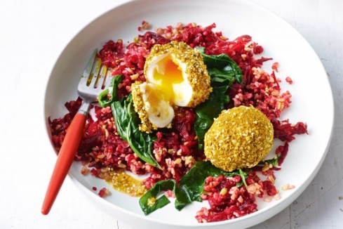
Club Sponsors

Greg Owens
Breeder & Exhibitor of Quality
Large Silver Laced
Fertile Eggs Available Now
Silver Laced Pullets Available from November

Wine Country Wyandottes
The Nightingale Family
Breeders and exhibitors of Quality Wyandottes
Large Varieties: Blue Laced Gold, Black, Gold Laced, Blue, Silver Laced, Red
Bantam: Blue Laced Gold, Black, Blue
Enquires welcome: 0418644766
www.winecountrywyandottes.com

